**Employee (Employee_ID is P.K)**

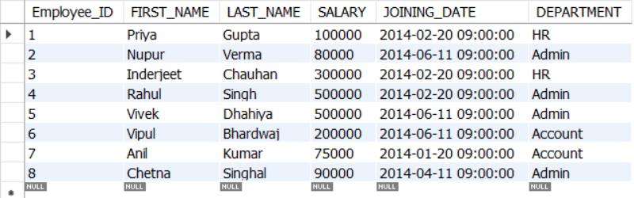

Create table Employee

(

Employee_ID int Identity(1,1) primary key,

FIRST_NAME varchar(50) not null,

LAST_NAME varchar(50) not null,

SALARY int not null,

JOINING_DATE datetime not null,

DEPARTMENT varchar(25) not null

)

**Bonus (Employee_Ref_ID is F.K)**

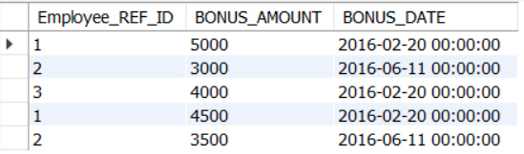

create table Bonus

(

Employee_REF_ID int,

BONUS_AMOUNT int,

BONUS_DATE datetime,

foreign key (Employee_REF_ID) references Employee(Employee_ID)

)

**Title (Employee_Ref_ID is F.K)**

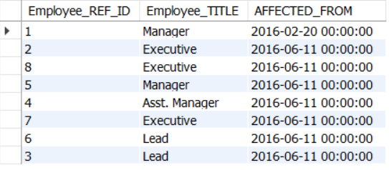

create table Title

(

Employee_REF_ID int,

Employee_TITLE varchar(25),

AFFECTED_FROM datetime,

foreign key (Employee_REF_ID) references Employee(Employee_a)

)

**You are required to create the above tables along with P.K and F.K constraints and then write the queries for the following questions**

#### **Find the First Record From Employee Table with all the text data in the Upper Case?**

select top(1) Employee_ID,Upper(FIRST_NAME),Upper(LAST_NAME),SALARY,

JOINING_DATE,UPPER(DEPARTMENT)

from Employee

#### **Select the record of a person who has highest salary in the Employee?**

select * from Employee

#### where Salary = (Select MAX(Salary) from Employee)

#### **Write a query to find out duplicate records from the Employee**

with duplicateCTE as

(select *,ROW_NUMBER() over(Partition by FIRST_NAME,LAST_NAME,SALARY order by Employee_ID) as Emp

from Employee

)

select * from duplicateCTE

where Emp > 1

#### **Find the Last Record From The Employee Table?**

select top(1) * from Employee

#### order by Employee_ID desc

#### **Find the Last 3 Records From Employee Table?**

select top(3) * from Employee

#### order by Employee_ID desc

#### **Get 3 Highest Salaries From Employee Table?**

select top(3) * from Employee

#### order by Salary desc

#### **List the department names of the Employee Table**

select distinct(DEPARTMENT) from Employee

#### **Display Odd Rows In EmployeeTable?**

select * from Employee

#### where Employee_ID % 2 = 0

#### **Display First Three Characters Of  FIRSTNAME From Employee Table.**

select Left(FIRST_NAME,3) from Employee

#### **Display the fullName by combining FirstName and LastName column along with the space between the FirstName and LastName**

select concat(FIRST_NAME,' ',LAST_NAME) FULL_NAME from Employee

#### **Display the employees in their sorted order by department in ascending and then by salary in descending order**

select * from Employee

#### order by DEPARTMENT asc, SALARY desc

#### **Display From Employees With The First Name As “Vipul” And “Vivek” From EmployeeTable.**

select * from Employee

#### where FIRST_NAME in ('Vipul','Vivek')

#### **Display the list of employees who has joined in Feb 2014**

select * From Employee

#### where Month(JOINING_DATE) = 02 and Year(JOINING_DATE) = 2014

#### **Display all the columns along with the running total by salary for each department from the employee table**

select *,Sum(SALARY) over(Partition by Department

order by EMPLOYEE_ID range between unbounded preceding and current row) as Running_Total

#### from Employee

#### **Display all the employees who never got the bonus using the Exists Clause**

select *

from Employee e

where not exists (select Employee_REF_ID from Bonus b

#### where e.Employee_ID = b.Employee_REF_ID)

#### **Display the 5th highest salary from the employee table**

select top(1) * from

(

select top(5) * from Employee order by salary desc) as T

#### order by T.SALARY

#### **Display the list of employees who have same salary**

select e1.Employee_ID,e1.FIRST_NAME,e1.LAST_NAME,e1.Salary

from employee e1 inner join employee e2

on e1.SALARY = e2.SALARY and e1.FIRST_NAME != e2.FIRST_NAME

#### and e1.LAST_NAME != e2.LAST_NAME

#### **Display the FirstName,LastName ,Employeetitle who have got the bonus of more than 4000**

#### **List the highest salary based on employetitle along with employee fullName**